
CS2106: Data Structures and Algorithms – Final Project

Notes:

- The top 3 class projects will get 100%.

- The choice of the programming language is up to you.

Requirements:

- Use 3 to 4 data structures that we covered in class(queue, stack, binary search tree, linked list, hash table,…) in a hypothetical real-life management system.

- Justify the use of the chosen data structures for the problem.

- Make a project poster of 24X36 (in inches) that will be presented in class.

- Creative ideas are encouraged and welcome!

Example of Project Idea:

A hospital management system involves scheduling incoming patients’ appointments with doctors based on the reason of admission to the hospital. Patients appointments are made on a first come first served basis. A doctor has a weekly hourly schedule where s/he is either: available for an appointment, on appointment, or outside office. If the patient already visited the hospital for the same doctor specialty, it is desirable that the patient be scheduled to the same doctor s/he previously visited.

- Doctor schedule can be represented using a 2-D array of dimension 7(days)*24(hours). The values inside the array (0, 1, or 2) can represent the 3 availabilities status of the doctor.

- Patients are scheduled an appointment with a doctor based the order of their arrivals, so a queue data structure of patients can be used.

- Patients record need to be stored for fast lookup. Therefore, a BST might be used to store the patient record with the SSN as the unique search key.

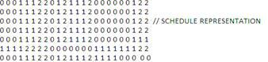

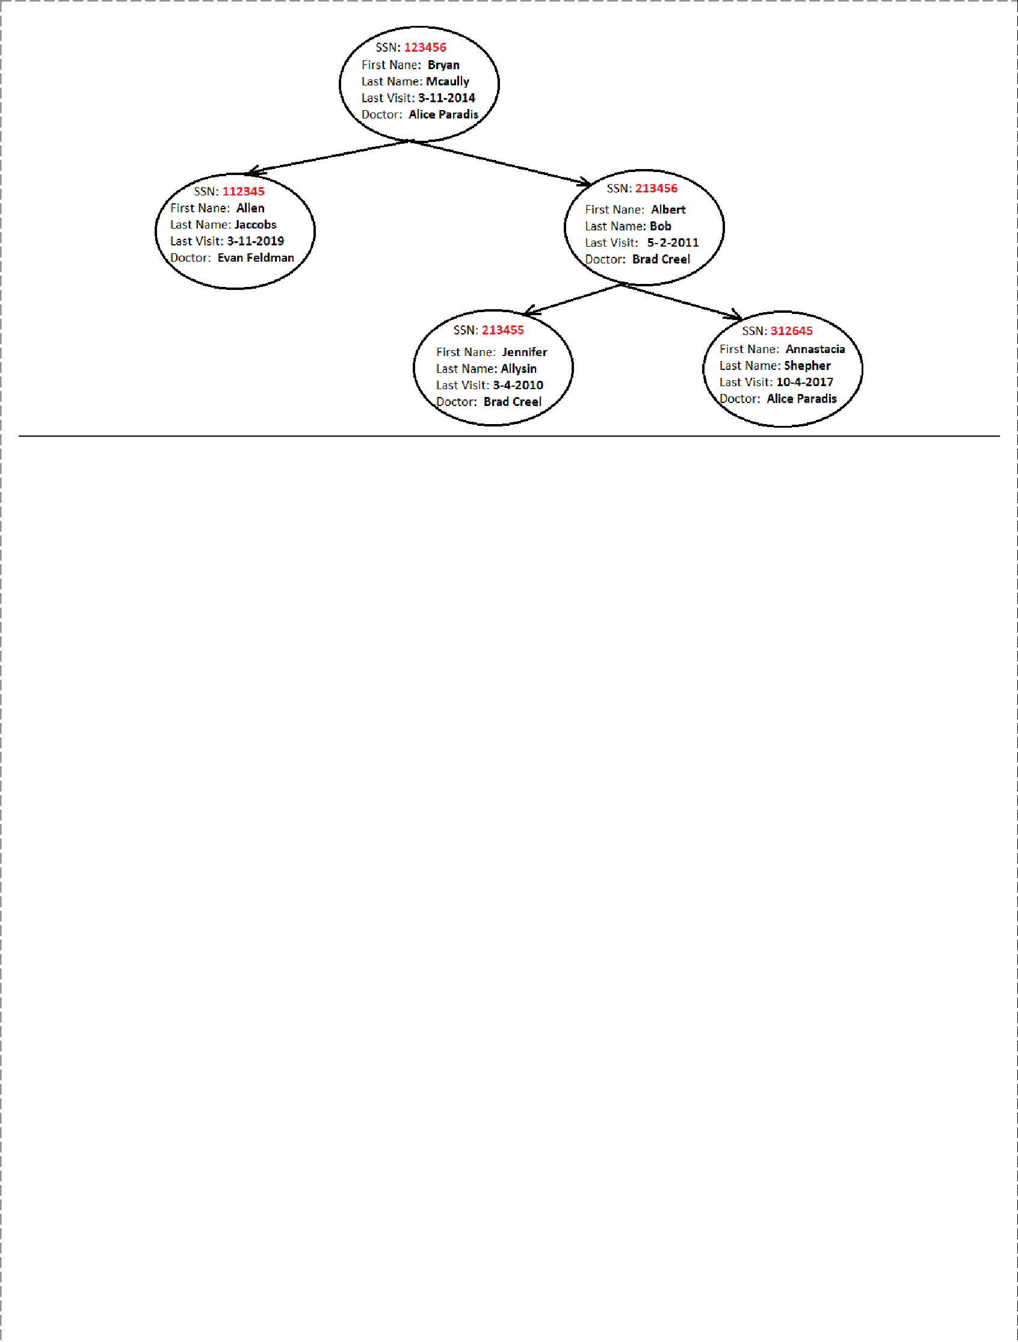

Example of Hospital Management Menu:

  - Lookup Patient Information

  - Add a patient to the queue

- Schedule Appointment for enqueued patients

      - Add New doctor

    - Lookup doctor Schedule

Example of Additional Functionalities:

- Group doctors by departments and schedule patients to doctors from the right department based on their symptoms (a symptom-specialty hash map can be used).

- Add dedicated nurses to each doctor and schedule an available appointment for the doctor and a nurse.

- Make a priority queue of patients based on the urgency of the patient case.

